Assignment: MongoDB, Knime, and API Integration
Name: Lalitha Lahari Karri
Date: Dec 5th 2025
Course: Enterprise Database Management
Part 1: MongoDB & Knime Connection
Objective: Connect to an external MongoDB source (Professor's Database), read Yelp business and review data, and migrate it to my personal MongoDB Atlas cluster.
Steps Taken:
- Connected to the source MongoDB using the provided credentials.
- Used KNIME MongoDB Reader nodes to extract the Business and Review collections.
- Established a connection to my personal MongoDB Atlas cluster using the SRV connection type.
- Used KNIME MongoDB Writer nodes to upload the data into my Yelp database.
Deliverable:
- Screenshot 1: Verification of Business and Review collections inside my personal MongoDB Cluster. 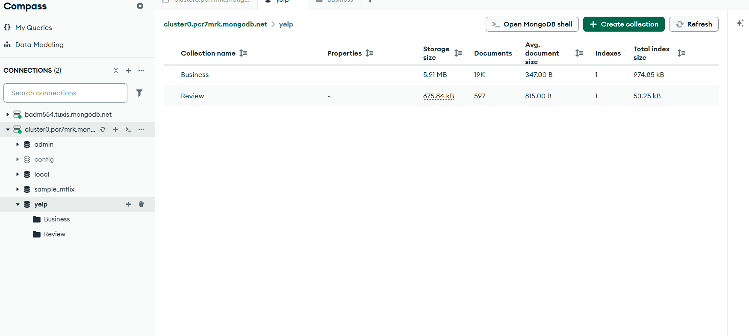
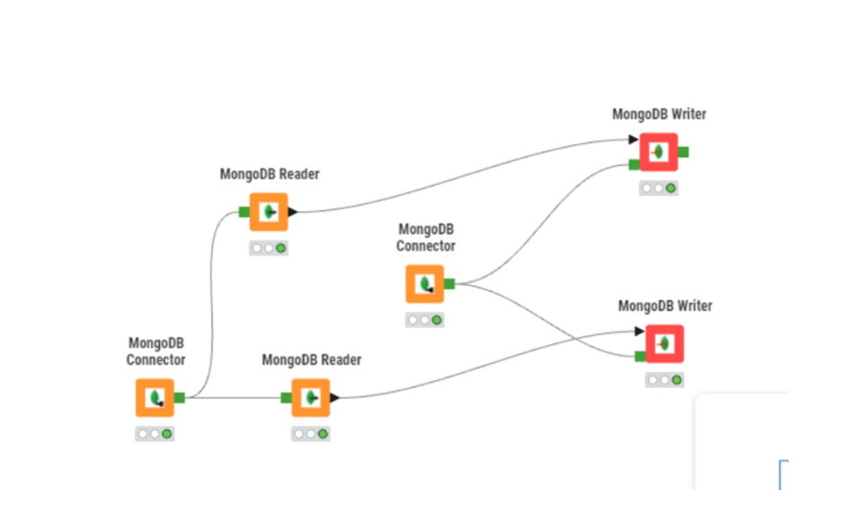

Part 2: Data Processing & Analysis
Objective: Join the Business and Review collections, filter for "Restaurants," and export the clean data.
Steps Taken:
- Reading Data: Retrieved the Business and Review collections from my personal MongoDB cluster into KNIME.
- Transformation: Converted the JSON structure into tabular format using JSON to Table nodes.
- Joining: Performed an inner join on the business_id column to combine reviews with business details.
- Filtering: Applied a Row Filter on the category’s column using the wildcard pattern *Restaurants* to isolate relevant data.
- Exporting: Wrote the final dataset to a CSV file named Lalitha_yelp.csv.
Deliverables:
- KNIME Workflow & CSV

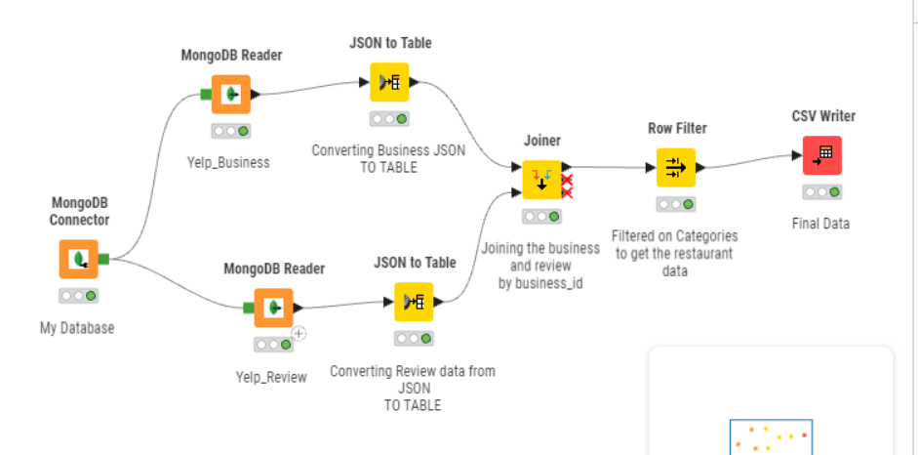
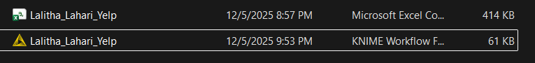
Part 3: ETL Pipeline (Dune Analytics to MongoDB)
Objective: Extract Stablecoin transaction data for Q3 2024 (July, August, September) using the Dune Analytics API and load it into MongoDB using Python.
1. Dune Query
I wrote a SQL query to aggregate daily transaction volume for major stablecoins (USDT, USDC, DAI, PYUSD) on Ethereum. The query was specifically filtered for the Q3 2024 time period.
- Dune Query Link: https://dune.com/queries/6306874
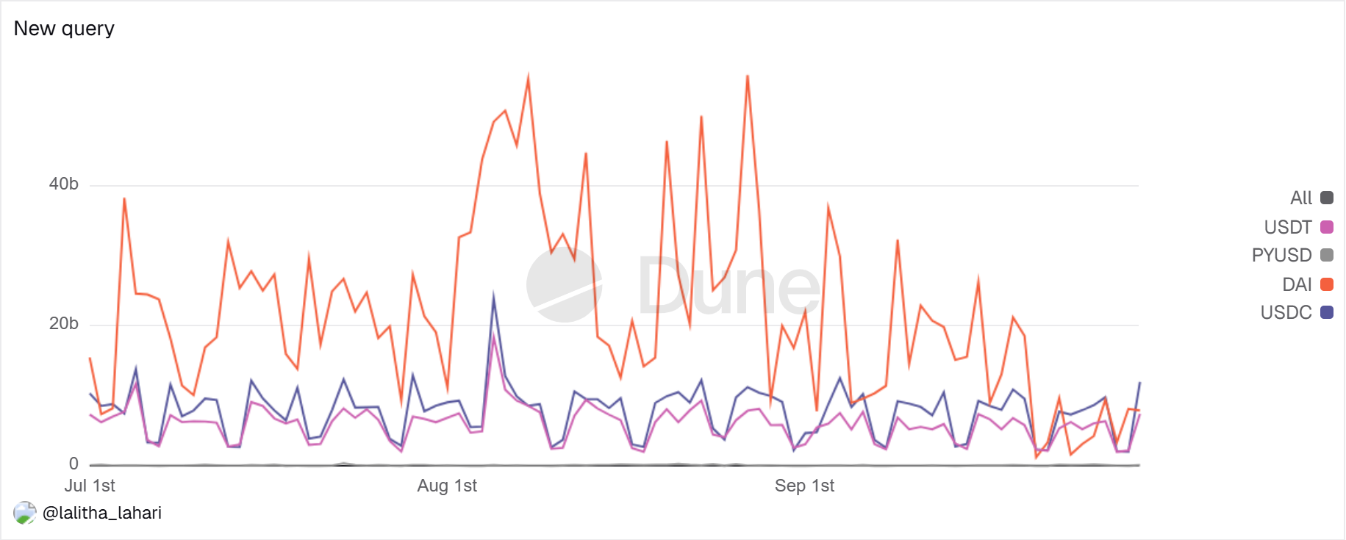

2. Python Extraction & Loading
I developed a Python script in Google Colab that:
- Connects to the Dune Analytics API using requests to fetch the query results.
- Connects to my MongoDB Atlas cluster using pymongo.
- Automatically creates the Stablecoin_Project database and Q3_2024 collection.
- Upload the fetched transaction data into the database.
Deliverable:
- Screenshot: Verification of the Stablecoin_Project database and Q3_2024 collection containing the uploaded data.
